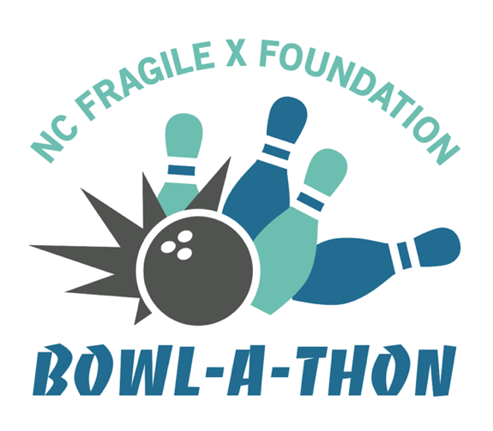
North Carolina Fragile X Bowl-a-Thon
Sunday, July 23, 2023
from 3 to 5 PM
Rainbow Lanes Family Fun Center
850 NC-42, Clayton, NC

2023 Bowl-a-Thon Pledge Sheet
The mission of the North Carolina Fragile X Foundation (NCFXF) is to improve the quality of life for those impacted by Fragile X through promoting awareness and understanding. This is accomplished by providing education, support and advocacy.
With a 501(c)(3) tax-exempt status, NCFXF works to connect families to services, to learn more about the Medicaid services available for families, and provide educational workshops. Your volunteer efforts and financial support are critical to the continued work of the NCFXF!

Name of Bowler: ______________________________________________________

 | _{SPONSOR} | _{MAILING ADDRESS} | _{PLEDGE}
1.
2.
3.
4.
5.
6.
7.
8.
9.
10.
11.
12.
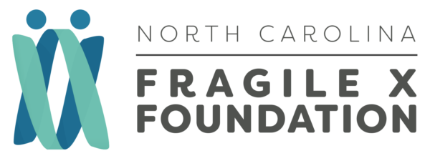
Visit our website:
ncfragilex.org
Donate online:
ncfragilex.org/donate

Bring all donations to the Bowl-a-Thon with your donation sheet(s).
Make checks payable to the North Carolina Fragile X Foundation.

